
TRUSTEES
PRESIDENT Nick Caiafa Russell Klug
CLERK Rosa Jos Robert Lima
Thomas F Deegan
Joan Golembiewski
Terri Sheridan
Marie Lukowski

April 3, 2024

2024 Wesley Terrace Water Main Improvements

Wesley Terrace from Eastwood Avenue to Lawrence Court

The Village has obtained a Contractor to install new water mains and fire hydrants in this area along with replacement of water service lines.

As part of this project, the new water main will be installed within the pavement on Wesley Terrace. Excavation work is anticipated to begin the week of April 8, 2024, with preliminary saw cutting beginning as early as April 8th (the exact date is weather dependent). Completion of the water main installation should take about 3 weeks and the Wesley Terrace portion of the 2024 Street Improvements will begin after the water main installation. We will keep you abreast of any significant changes to the schedule.

As in all construction, we expect that you will experience some inconvenience. During water main installation work, parking will be prohibited where the work is taking place. We are asking residents to avoid street parking between 7:00 AM and 5:00 PM, Monday through Friday, to allow for a safer work environment for the Contractor and to assist roadway traffic flow.

The Village understands that this project will cause some disruption in your daily activities and would appreciate your patience and understanding while it is underway. These disruptions will include a couple of brief (roughly 3 - 4 hours) interruptions in your water service. You will be further informed about these issues later by either the Village or the contractor to provide as much notice as possible.

Please be careful while driving in the area and watch for signage about road closures, parking restrictions, or detours. Also please do not disturb the small “locate” flags around your lawn and parkway – these flags mark the location of various underground pipes and wires so they are not accidentally struck while digging is underway. It is also important to let the Village know if you have an irrigation system in the parkway because it will help avoid damage to it during the water main project.

Once the water main project is complete, the new water main will benefit all the residents in the area. Please contact the Project Engineer at (847) 212-8268 or the Village at (847) 678-2550 with any concerns or questions. In addition, updates on the project will be available on the “Construction Updates” section of the Village website.

Sincerely,

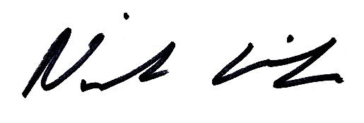

Nick Caiafa
Mayor

