Creating a BSAO Account
Before you’re able to register for AutoPay or Paperless billing, you will first need to create an account through BS&A Online that registers the property to your account. To do so, use the link provided from your municipality and go to the BSAO site.
Use the Register dropdown to create your new account
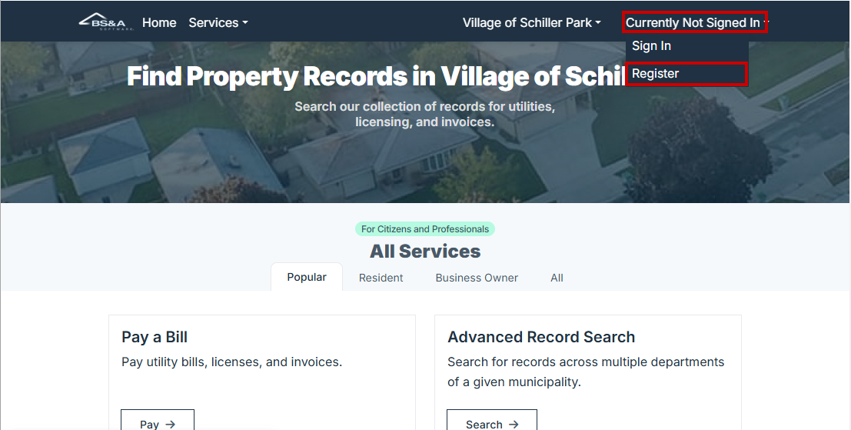
Fill out all required fields and select Create Account
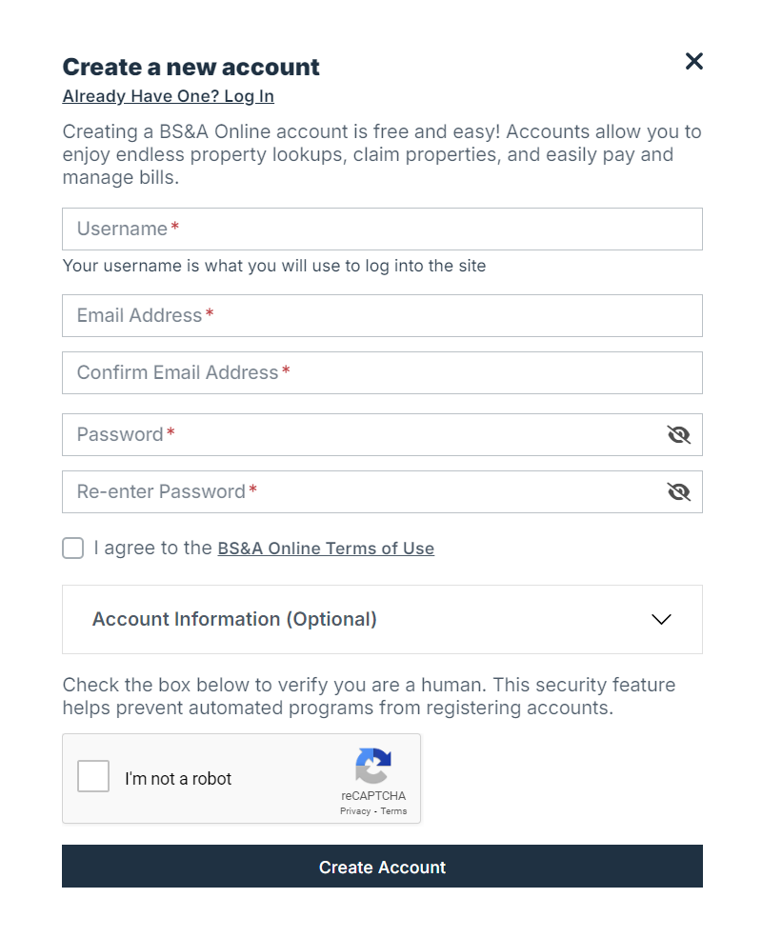
After the Account has been Created
You will now need to make a payment on that account while you’re logged in and it will register it as your property. You can also Claim is as Your Property
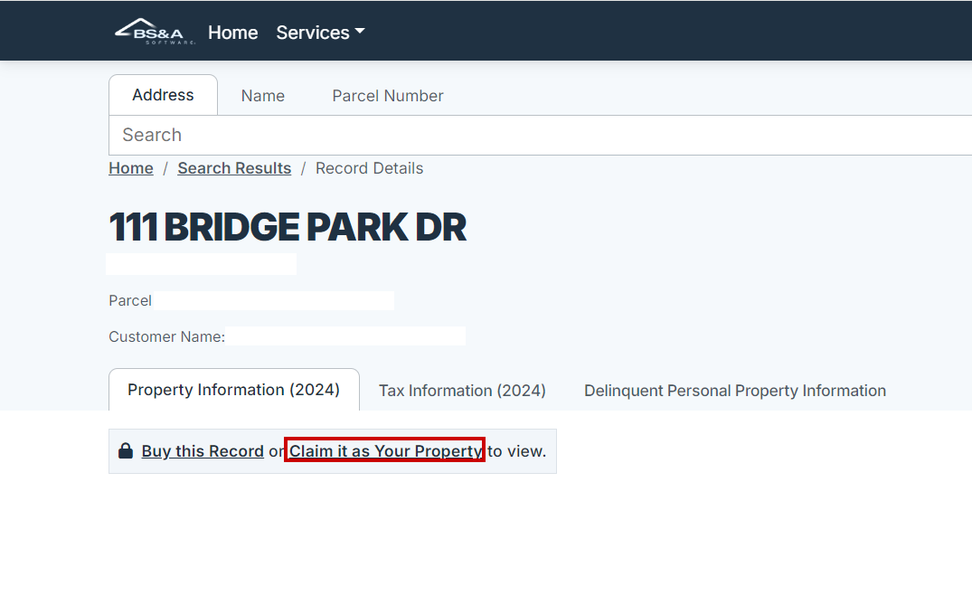
After it has been registered, please follow the next steps to enroll in AutoPay and/or paperless billing.
BS&A Payments AutoPay checkout enrollment
As a resident user, you can enable Automatic Payments in the checkout flow. There is a checkbox that must be selected in the Payment Summary screen. The resident user must have a saved payment method for AutoPay enrollment. 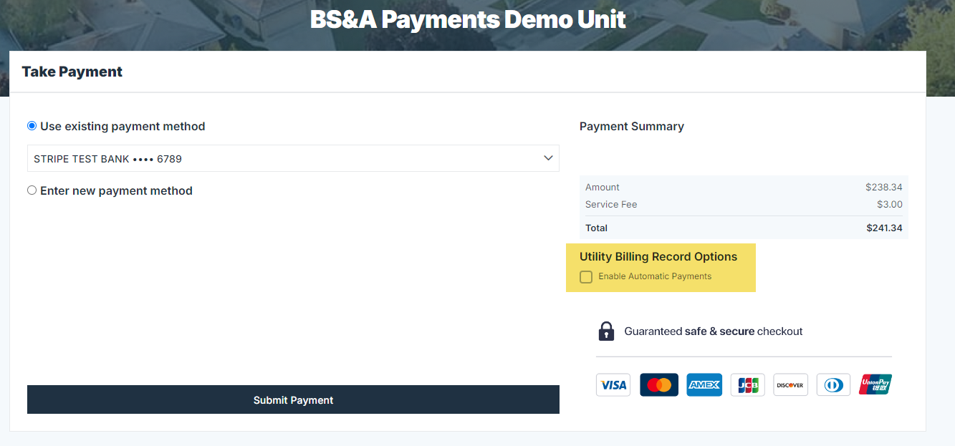

Additionally, once a bill has been paid, it will be displayed under the My Account > Bills tab. Here, the residents will see each of their bills they’ve previously made a payment for display. On the right-hand side is an Enroll in Autopay button. The resident can complete Autopay enrollment from the screen by selecting an existing saved payment or creating a new saved payment method.

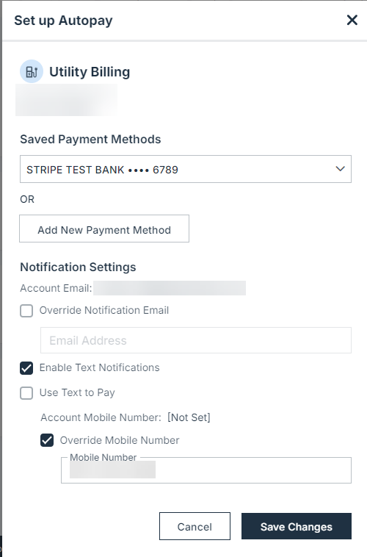
Paperless enrollment is also completed from the same Bills view where AutoPay can be configured. 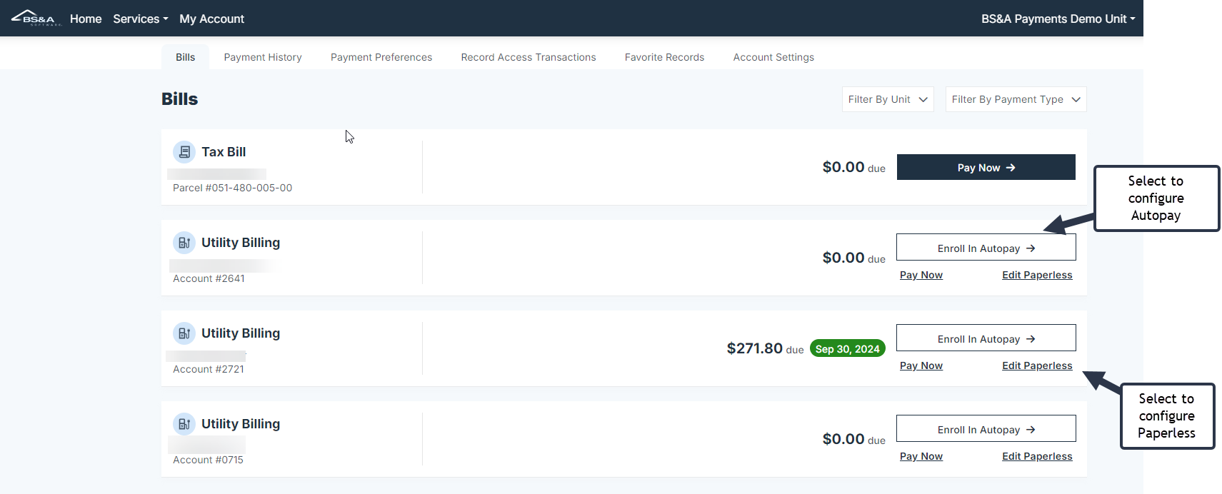

Complete the following after selecting Edit Paperless for paperless billing enrollment.

