How to Check the Status of or Print Your Business License

Step 1:
- Sign up for BS&A Online or log into your previous account HERE
Step 2:
- Once you are logged in, Click the Services Tab

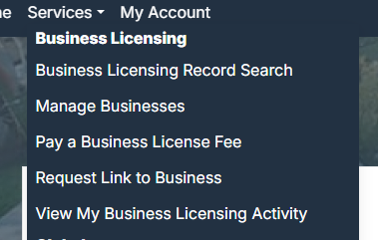
Step 3:
- Select “Manage Businesses”


Step 4:
- Search for your Business by using the unique PIN given to you
- If you do not have a pin, please follow the link below or call us at (847) 678-2550

Step 5:
- View the Status of your Business!
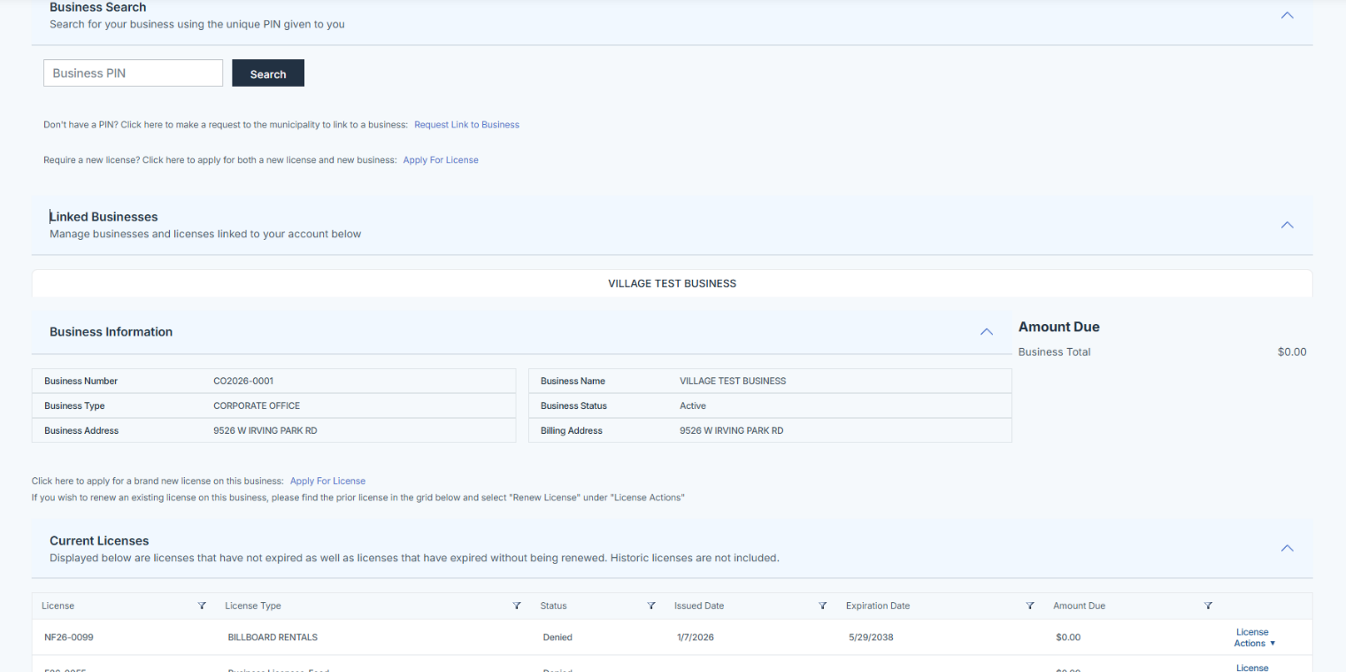

Step 6:
- TO PRINT YOUR LICENSE, click License Actions and select Print
